**Resource Diagram**

Venues are the prime resource of the app, the data related to venues will be stored in the firebase database field. There will be two types of venues available to the user for booking, and they are 1. Convention Hall 2. Restaurants.

**Venue**

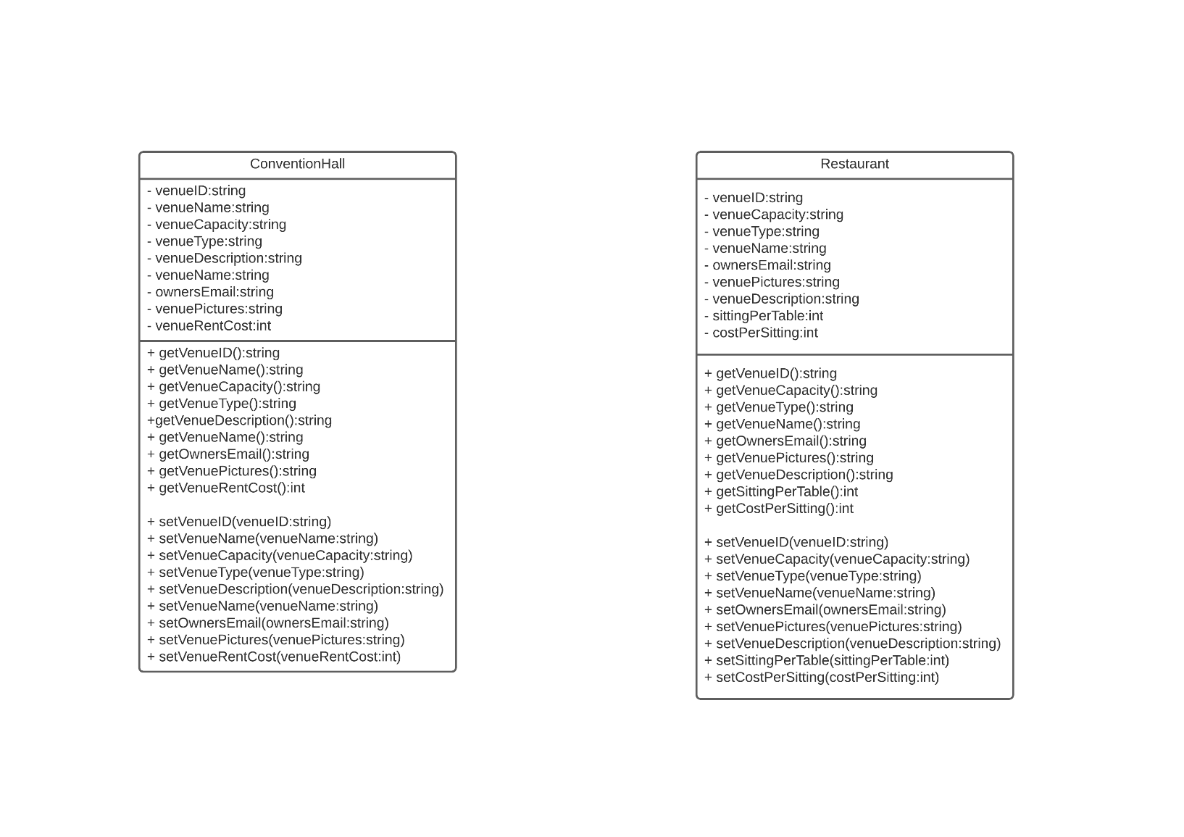

Convention Halls can be booked as a whole and Restaurants can be booked based on availability of tables.

There will be two types of users using the app, 1. Owner and 2. Customer

The owner-user will be able to open venues of both types for booking from their app and the customer-user will be able to search and book those venues as they desire from their app.

Below is the working diagram of the resources with both type of user.

**Owner-user Work Diagram**

Owner App

Post The Venue for Booking

Add Information to The Venue

Open Venue (Any Type)

**Customer-user Work Diagram**

Confirm Booking

Make Payment

Select Time Slot

Select Date for Booking

Search for Venue

Customer App